0.6-V, μW-Power Four-Stage OTA With Minimal Components,
and 100× Load Range
Proposed 0.6-V Four-Stage OTA
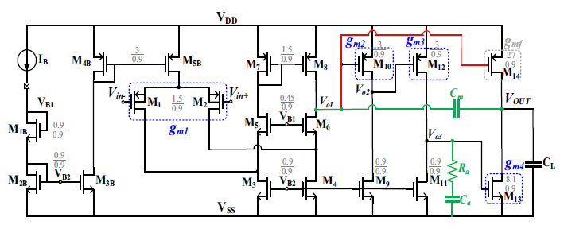
Implemented Circuit in Cadence Virtuoso
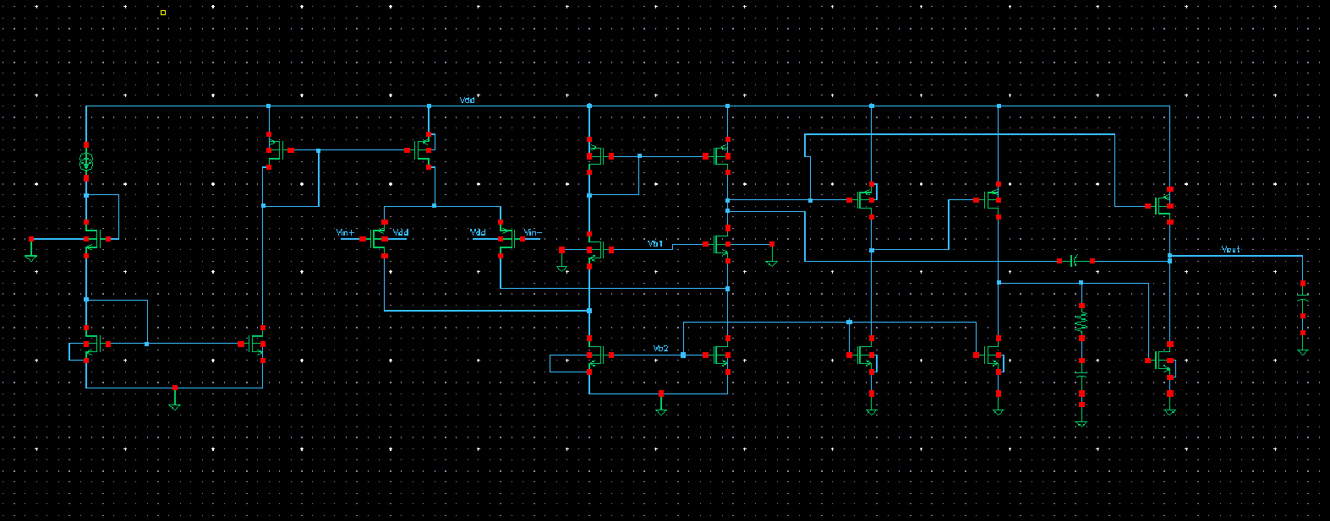

Simulation & Result
Reference Current = 180nA and Vdd = 0.6V in 65nm Cmos Technology
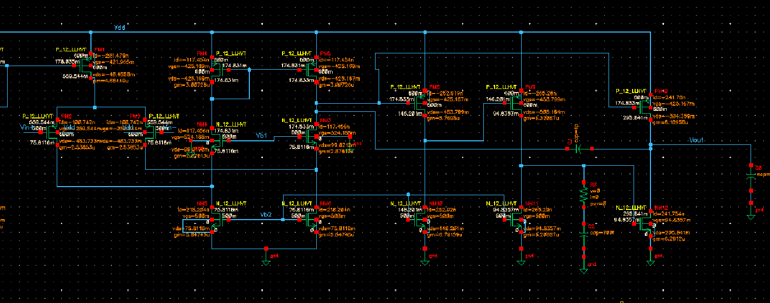
Multi Stage Gain
1st stage gain = 31 DB
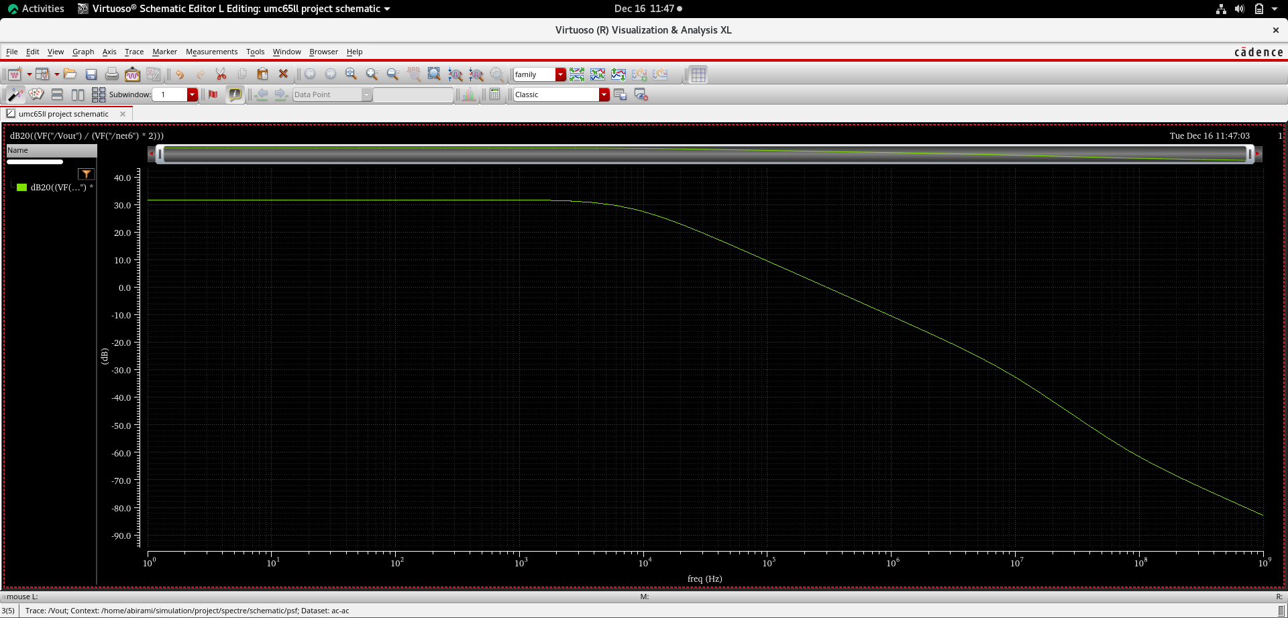
2nd stage gain = 48 DB
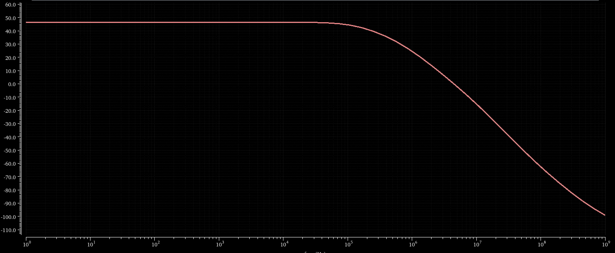
3rd stage gain = 54 DB
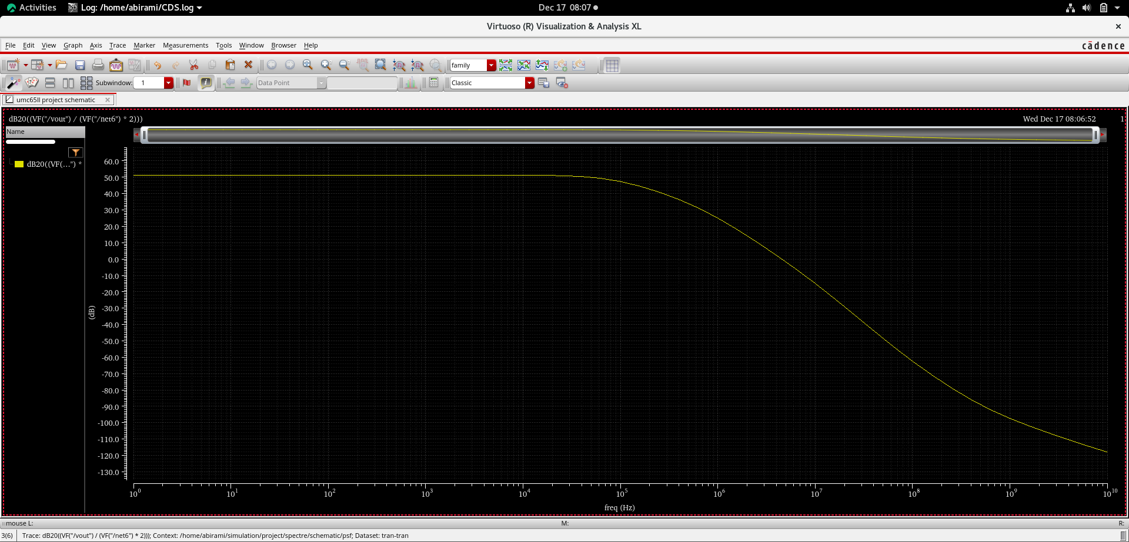
Gain & Phase
- Gain = 77.93 db
- PM = 180 – 149 = 31
- For Peaking Compensation
R_{a} = 400K
C_{a} = 700 fF
- UGF = 986.25 KHz

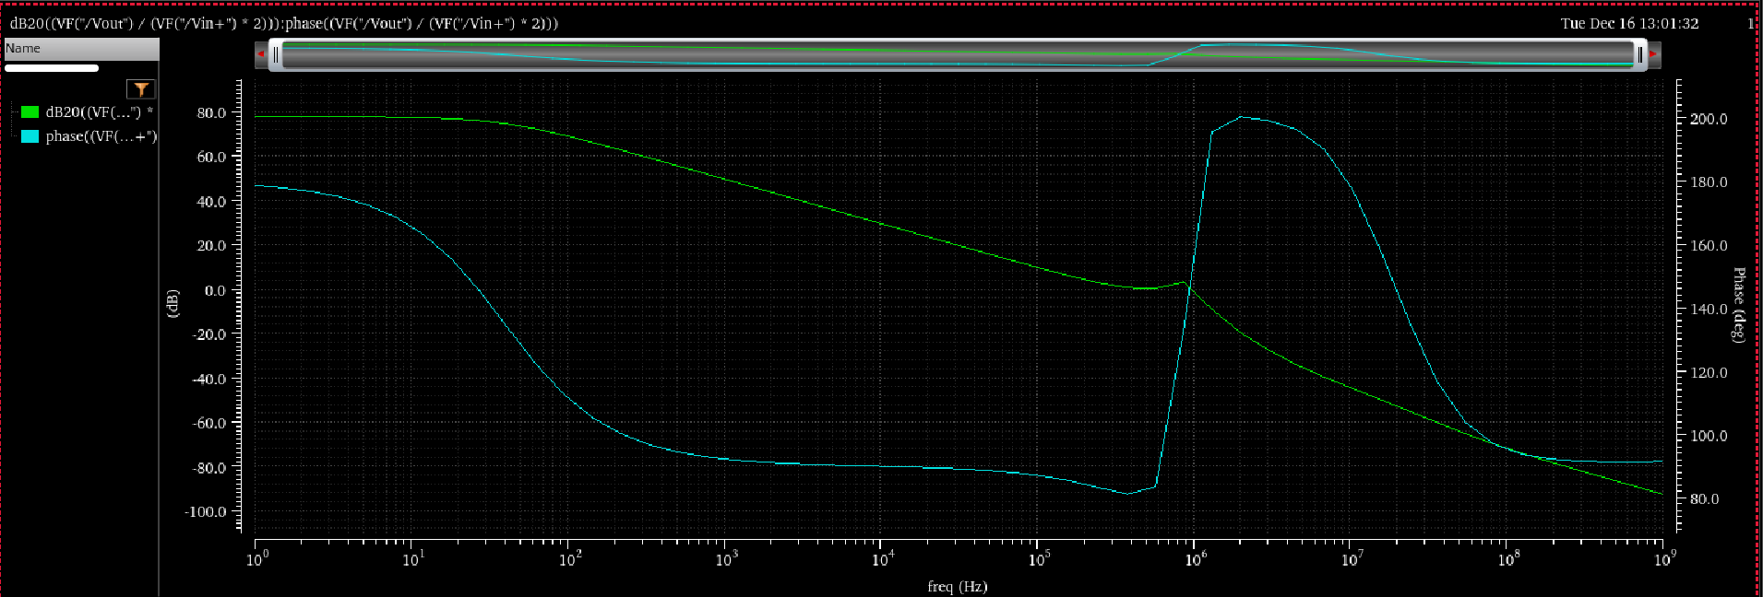

AC Common Mode Gain
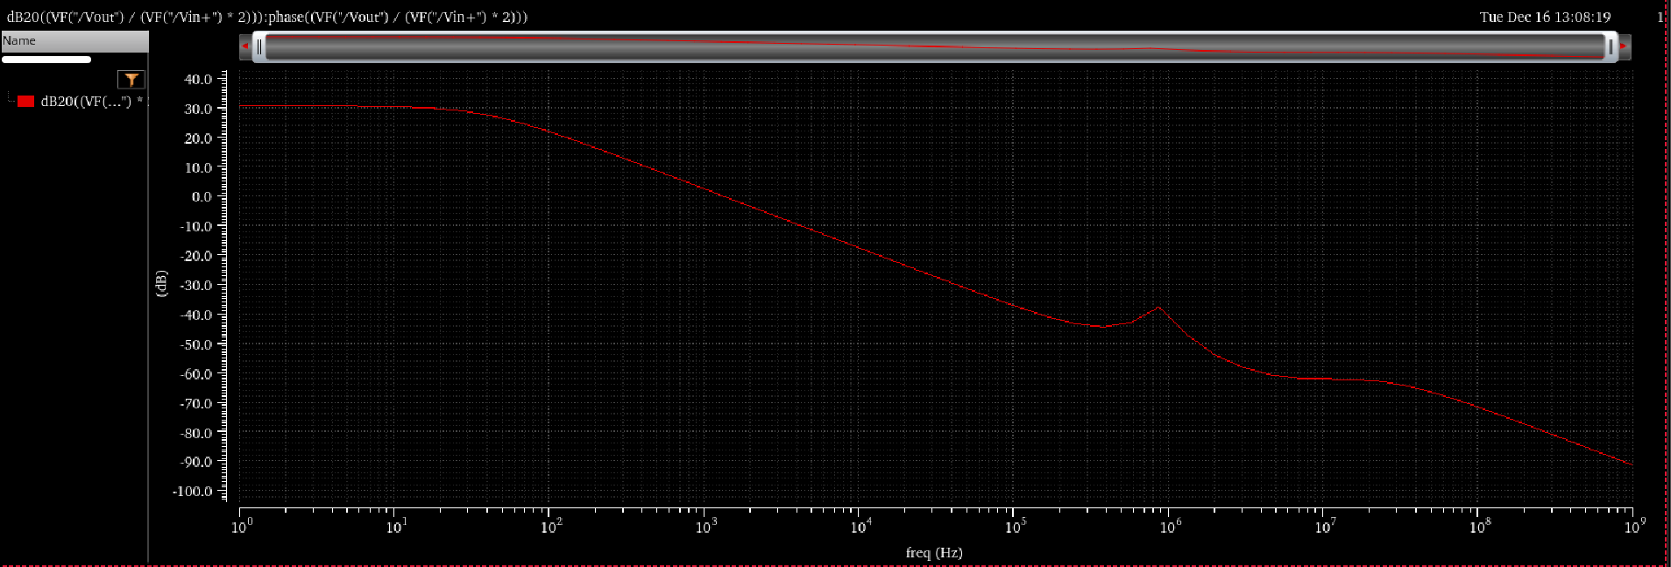

Input Reffered Noise
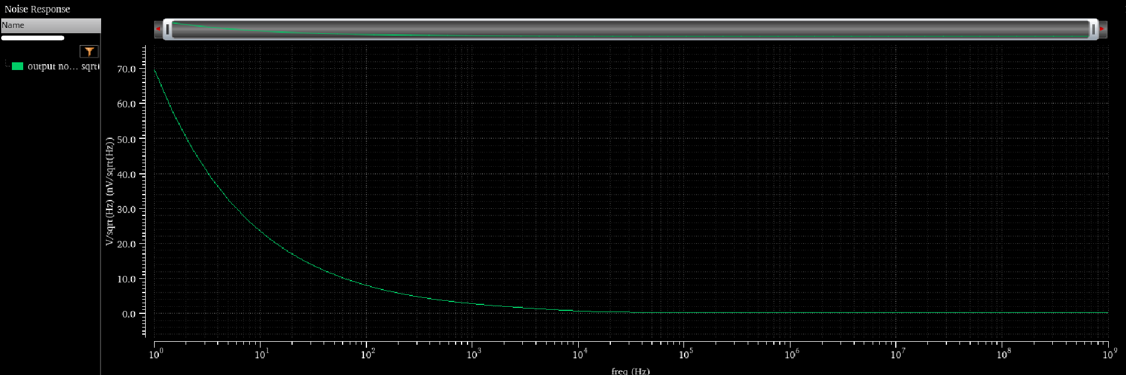
Output Reffered Noise
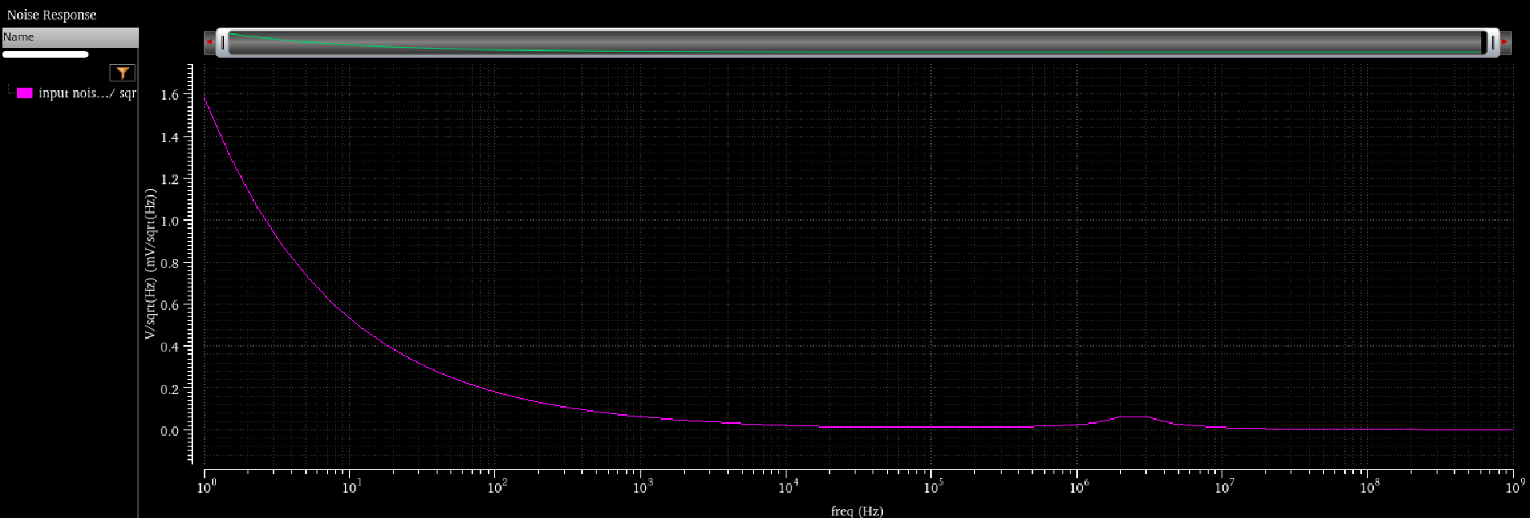

CMRR
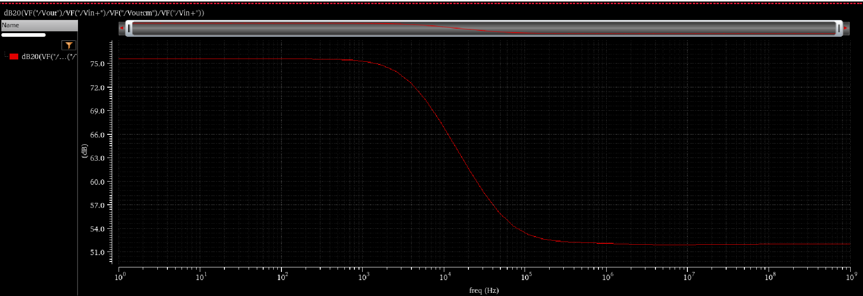

PSRR
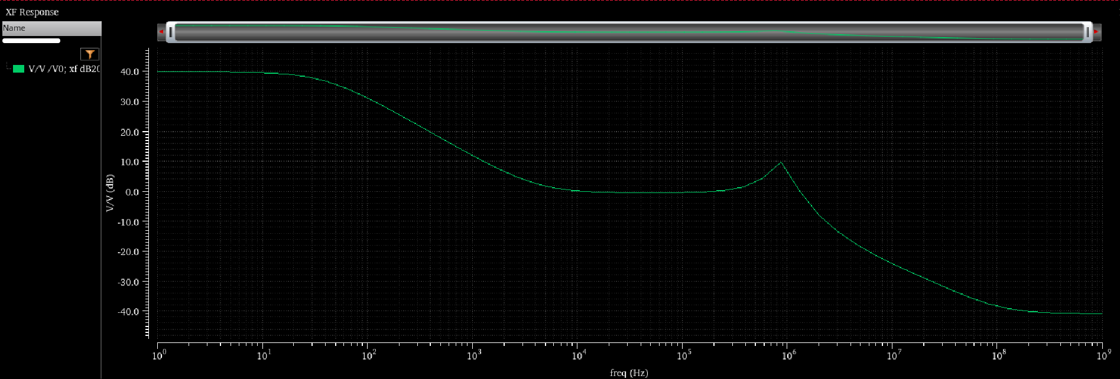

Comparison of Original And Our Work
Parameters | Original Work | This Work
Technology(nm) | 180 | 60
No of transistor | 14 | 14
Vdd | 0.6 | 0.6
Gain (db) | 119 | 78
CMRR (db) | 182 | 75
PSRR (db) | 51 | 39
Noise (nV/sqtHZ ) | 750 | 63.2

Reference
https://ieeexplore.ieee.org/document/10707245

